**Lab 5,6 (merged)**

***(Show input and output side by side for all problems****)*

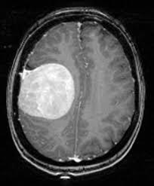

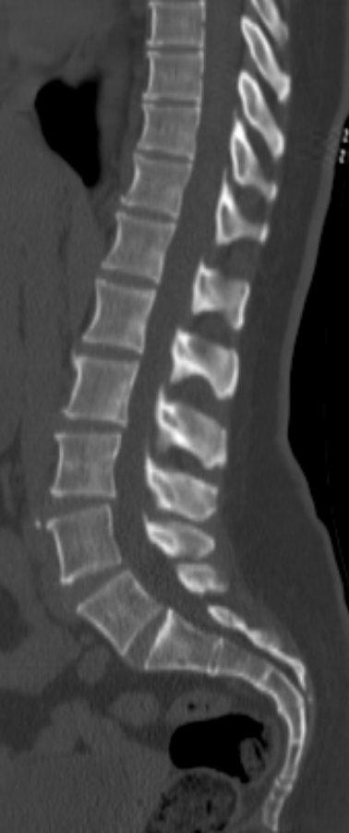

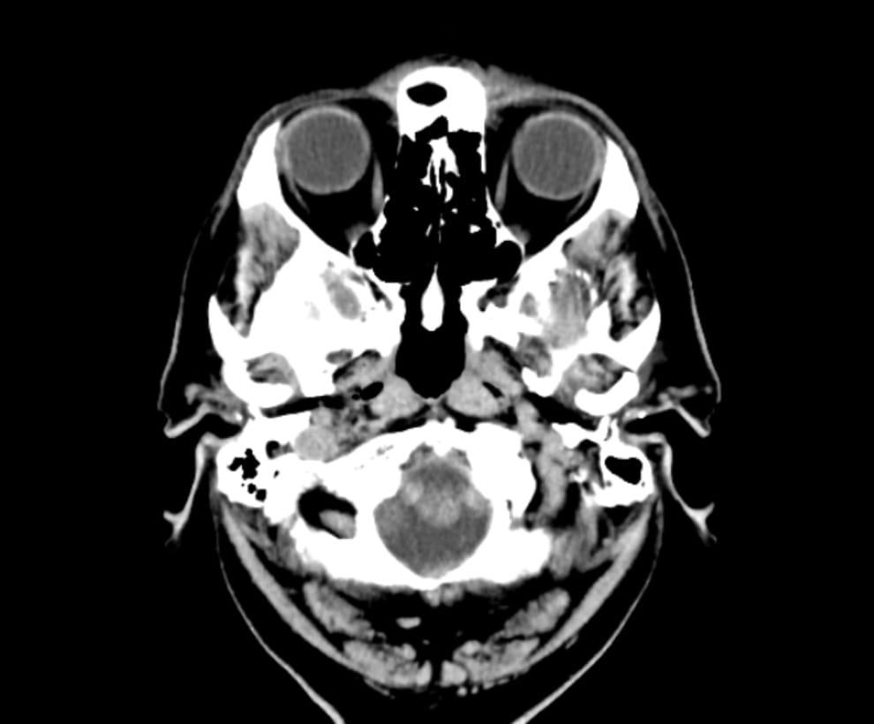

1. **Apply** Fourier transform to transform any image (above) from the spatial domain to the frequency domain. Apply inverse Fourier transform to transform the image from the frequency domain to the spatial domain.

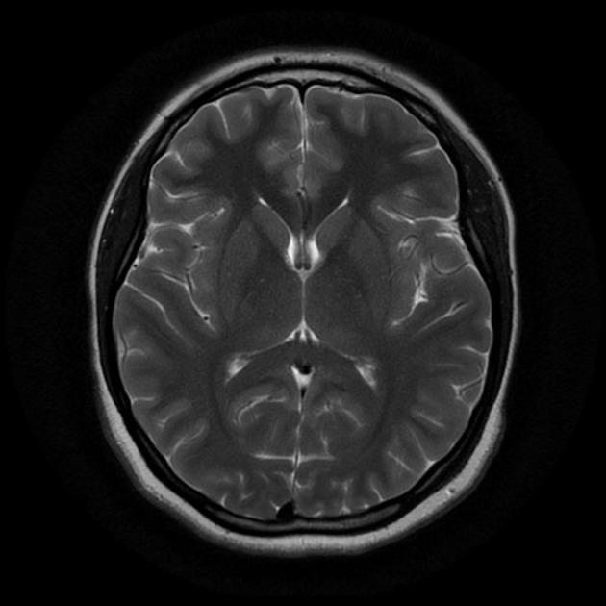

**Figure 1:** Brain MRI

1. **Apply** three types of high pass filtering in the frequency domain in **Figure 1** andfind out which one is better to produce the enhanced image (sharpen) for the given image (output must show all steps as shown in **Figure 2**).

i. Ideal high pass filter (IHPF)

ii. Butterworth high pass filter (BHPF)

iii. Gaussian high pass filter (GHPF)

1. **Apply** three types of low pass filtering in the frequency domain in **Figure 1** andfind out which one is better to produce the smoothen image for the given image (output must show all steps as shown in **Figure 2**).

i. Ideal low pass filter (ILPF)

ii. Butterworth low pass filter (BLPF)

iii. Gaussian low pass filter (GLPF)

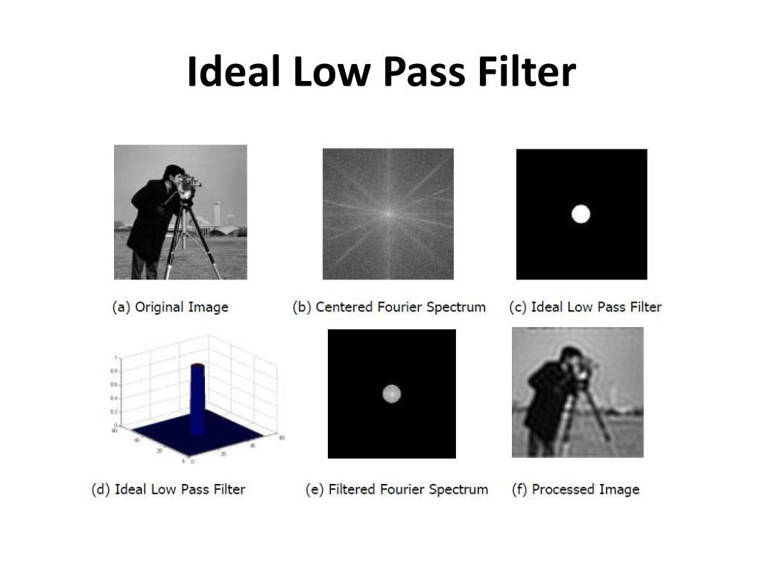

**Figure 2: Sample Output of Ideal Low Pass Filter**

**.(Show input and output side by side for all problems)**

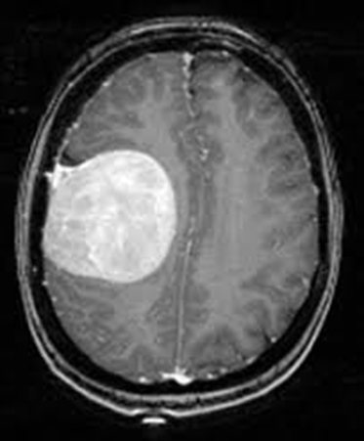

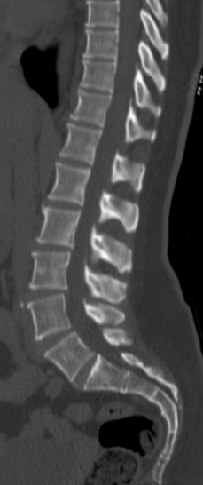

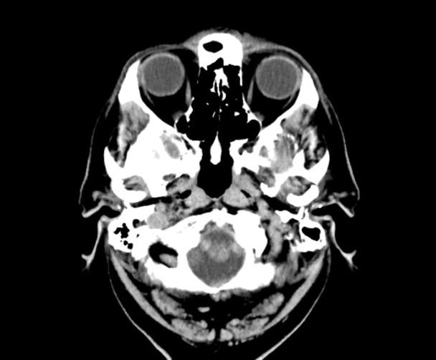

**4.** **Compress** the above images using Discrete Cosine Transform (DCT), Haar Transform, and DCT-Haar, and find out which one is better in terms of compression ratio and PSNR for the given images.

**5.** **Apply** Gaussian noise to Figure 1, and then use the following to restore the image:

i. Geometric Mean filter

ii. Harmonic Mean filter

iii. Contra-harmonic Mean filter

**6.** **Apply** Gaussian noise to Figure 1, and then use the following order statistic filters to restore the image:

i. Median filter

ii. Maximum filter

iii. Minimum filter

iv. Midpoint filter

v. Alpha-trimmed filter

vi. Trimmed filter

**7.** By observing and comparing each of the outputs, determine which filter restores the image Figure 1 closest to its original state. Mention the reasoning behind your observation.

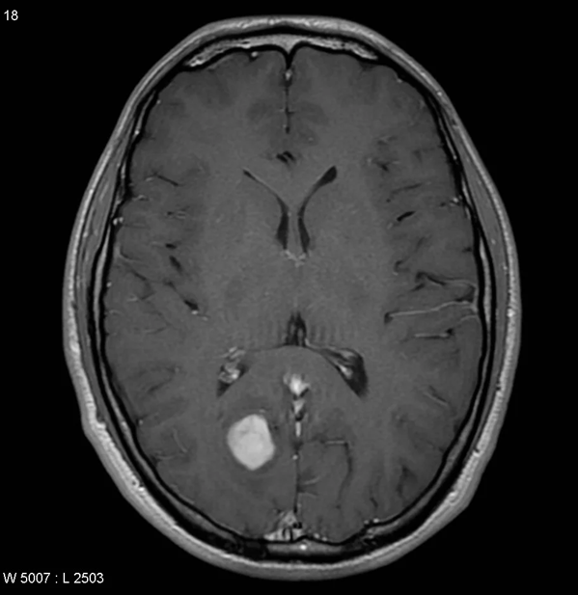

**Figure 1: Tumor -1**